Peace Circles
​
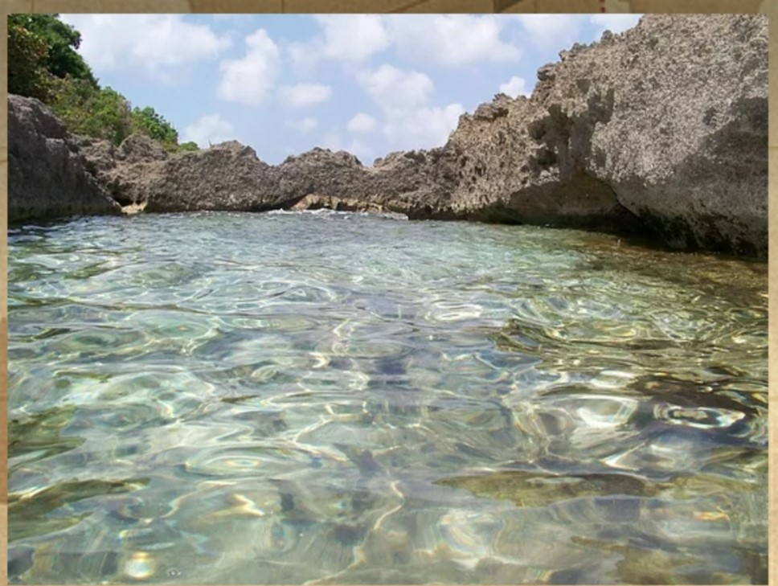

In the Silence of meditation find the truth of your soul & connect with the peace every soul is longing for. . .
Learn the undeniable Truth of our oneness as a human family
Bring healing within yourself and heal others you care about
Experience the vibration of Peace your soul seeks to know
Feel the infinite Love of the Divine Mother for us, Her children
Embrace the energy of the Divine Mother’s womb, the true power of Creation.

Peace Circles meditations provide the opportunity to find freedom from the
sense of self/ego and redirect the focus on the growth of our soul. . .
assisting us in moving out of our drama and into our Dharma!
It is then that our "story" changes and we see life through different eyes, through the eyes of our soul.

Vasi 340-626-3256 SaiAumCreations1008@gmail.com St Thomas US Virgin Islands

